Binary 3

Fixed-point vs Floating Point Numbers
If you have a five bit computer and you want to represent (unsigned) binary in fixed point, all numbers in that computer have to have the same point.
8 | 4 | 2 | 1 | . | 0.5
0 | 0 | 0 | 0 | . | 0
1 | 1 | 1 | 1 | . | 1

The maximum and minimum values you can represent are 0₁₀ and 15.5_{10.}
1 | . | 0.5 | 0.25 | 0.125 | 0.0625
0 | . | 0 | 0 | 0 | 0
1 | . | 1 | 1 | 1 | 1

Here, the maximum and minimum values you can represent are 0₁₀ and 1.9375₁₀. So here, you have more precision.

What if you want to represent a range of large numbers as well as precise numbers? Well, you can’t do that in fixed-point binary. However, in floating-point, you do.

Scientific notation is a common way to represent large or small decimal numbers in a concise format.
- Numbers in scientific notation have two parts: the significand (or mantissa) and the exponent
  - 1.45x10⁻⁵ (=145000)
  - 4.2159x10⁻⁷ (=0.00000042159)
  - 3.28x10⁸⁰ (32800000000000000000000000000000…)
- We can also represent binary numbers in this form
  - 1.0101x2⁵ = 101010₂ = 42₁₀
  - But how do we store this type of binary format in a computer?

IEEE-754
The IEEE (Institute of Electrical and Electronics Engineers) specified a standard for representing floating-point binary numbers.
- The two version of the format that are most common are single precision (32-bits) and double precision (64-bit)
- The formats specify:
  - A number of bits for the significand and exponent
  - A bias for the exponent
  - A normalised format (hidden leading bit in significand)
Format | Sign | Exponent | Significand | Total
Single | 1 | 8 | 23 | 32
Double | 1 | 11 | 52 | 64

- The sign bit works the same as in signed magnitude.
- The exponent and significand are not just unsigned binary.
We need to be able to represent negative values in the exponent.
- IEEE-754 format specifies a bias for the exponent.
- The bias is 127 for single precision and 1023 for double precision.
- We subtract the bias from whatever value is stored in the exponent
- Example: convert the single precision exponent 01111010₂
  - 01111010₂ = 122₁₀
  - Subtract bias: 122₁₀ – 127₁₀ = -5₁₀
- We use a bias because it allows the numeric ordering to be the same as the lexicographic ordering (which makes it fast to compare the size of two numbers)
- These numbers are specific to allow us to represent an equal number of positive and negative exponents.

The significand is normalised. There is an implied leading 1. before the stored significand.
e.g.: 01011000000000000000000000 –> 1.01011000000000000000000000
- By doing this, we effectively gain an extra bit of precision in the significand because of the implied leading 1
- It also ensures that there is a unique representation for values.
  - e.g.: in non-normalised form, the following are representations of 2.5:
  - 10.1 x2⁰
  - 1.01 x2¹
  - 0.00101x2⁴
If you have a bit larger than the significand, you need to round.
- If our exponent is larger than 128, we would have an overflow where the number is simply too large to store in the format.
- Here you can move to double precision.
Using just normalised form would mean it is not possible to represent 0. Instead, IEEE-754 format specifies a special value for 0.
- There are also special values for positive and negative infinities, and n ot a number values, among others.
Decimal | IEEE-754 single precision
±0 | 0/1 00000000 00000000000000000000000
±infinity | 0/1 11111111 00000000000000000000000
NaN | 0/1 11111111 (any non-zero significand)

Arithmetic with IEEE-754
To add two floating-point numbers:
- Adjust the position of the points so that the two significands have the same exponent
- If numbers have the same sign, add the significands. If numbers have different signs subtract the smaller significand from the larger significand
- If needed, renormalise the significand and adjust the exponent
- Select the correct sign bit
To multiply two floating-point numbers:
- Add the exponents
- Multiply the significands
- If needed, renormalise and set exponent
- Select the correct sign
Subtraction: a-b = a + (-b)
Division: Same as multiplication, but in Step 1. subtract the exponents and in Step 2. divide the significands.
There are a number of errors in floating point arithmetic:
- Overflow: the magnitude is too large to store the format
- Underflow: the magnitude is too small to store in the format
- Catastrophic cancellation: lack of significant figures to represent the result of colliding large and small numbers
  - e.g. x + y = x where x is a large number and y is a small number
- IEEE-754 doesn’t have exact representations for common Base-10 numbers:
  - e.g. 0.2 + 0.1 = 0.300000000000004
  - This is a number in general for representing decimal in binary format

Range, precision and accuracy
The range is a difference between the maximum value and the minimum value that are representable in a given format.
- The range of double precision numbers is shown below
- Range doesn’t mean all values are representable within that range
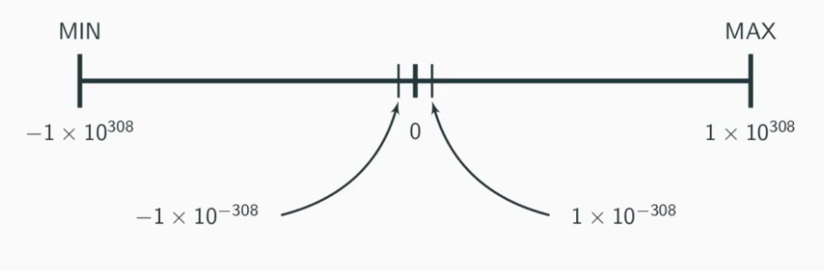
The precision refers to how much information a representation gives us of a value.
- eg.
  - 3.14 has 2 digits of precision right of the decimal point
  - 3.149 has 3 digits of precision right of the decimal point
  - 3.140 has 3 digits of precision right of the decimal point
- More precision doesn’t necessarily mean more accuracy.
  - 3.14 is a more accurate representation of π than 3.149, even though it is less precise.
Accuracy refers to how close a representation of a value is to the true value.
- For example, we know that there is no exact representation of 0.3 in bianry but we have different levels of accuracy with binary representations.
  - In 5-bit fixed-point binary, with the binary point between index 4 and index 3, the most accurate representation of 0.3 is 0.0100 = 0.25
  - In IEEE-754, the most accurate representation of 0.3 is 00111… = 0.300000011920928955078125
- Relative error is a measure of the accuracy of a representation
  - Relative error = T – R / T * 100, where T is the true value and R is the value that is represented.

